**Project Development Phase – Sprint 4**

|  |  |
| --- | --- |
| Date | 05 November 2022 |
| Team ID | PNT2022TMID40519 |
| Project Name | Developing a Flight Delay Prediction Model Using Machine Learning. |

**Sprint 4 Output**

**Local Host**

**User inputs**

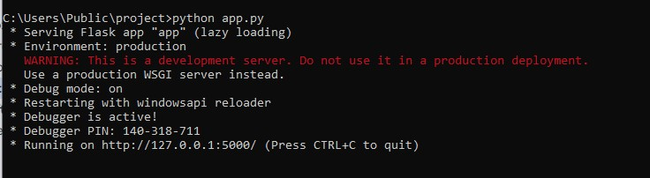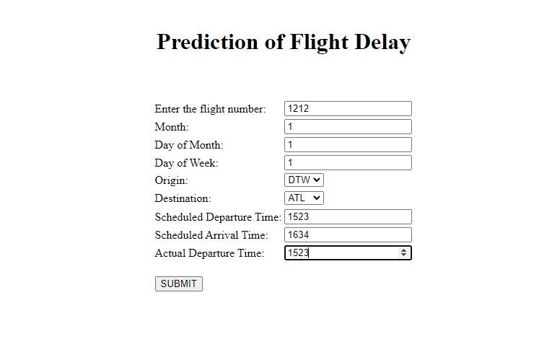

**Final Output**

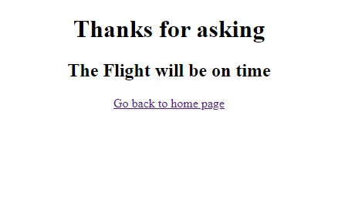

**Cloud Deployment**

